**GAME DESIGN DOCUMENT**

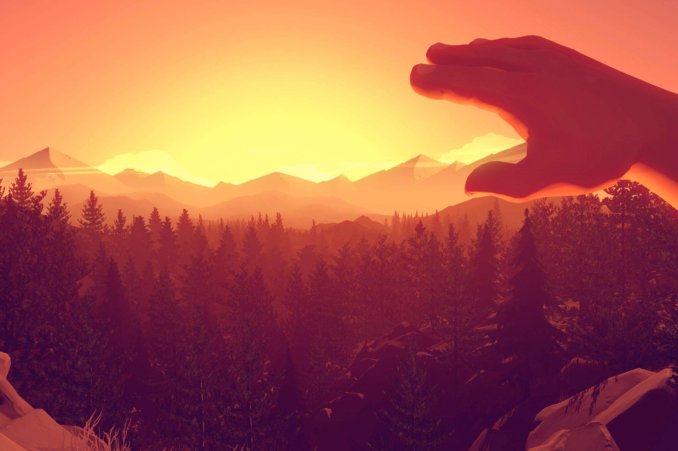

**FIREWATCH**

TABLE OF CONTENTS

**Game analysis** 3

**Mission statement** 3

**Genre** 3

**Platforms** 3

**Target Audience** 3

**Storyline & Characters** 4

**Gameplay** 7

**Overview of Gameplay** 7

**Player Experience** 7

**Game Objectives & Rewards** 7

**Level Design** 8

**Control Scheme** 10

**PC controls :** 10

**Console controls :** 11

**Steam Controller :** 11

**DualShock Controller :** 11

**Xbox One Controller :** 11

**Schedule & Tasks** 12

# **Game analysis**

Firewatch is an atmospheric story driven game about the main character Henry which is controlled by you (user). Henry walks and explore around the woods, listening to Delilah's instructions through walkie talkie, she narrates you through the game and helps you out to solve the mystery which is later revealed.

# **Mission statement**

The artstyle, both with the narrative story and great dialogs is what will drive people to play this game. You who will play as Henry, will enjoy in beatifull surroundings and explore the world of firewatch with very interesting and mysterious story along the way.

# **Genre**

Firewatch is an atmospheric first person, story driven, walking simulator

# **Platforms**

PC – Windows OS 7 or later, OS X, Linux

CONSOLE – Play Station 4, Xbox One, Nintendo Switch

# **Target Audience**

Game is mostly targeted towards people who enjoy playing story driven atmospheric games with interesting story along the way. It targets the people who like spending most of their time alone and in nature, the people who enjoy calming and aestethic surroundings with mystery twists. Generally speaking we are talking about both men and women between 15 – 60 years old

# **Storyline & Characters**

After his wife develops early-onset [dementia](https://en.wikipedia.org/wiki/Dementia), Henry takes a job as a [fire lookout](https://en.wikipedia.org/wiki/Fire_lookout) in [Shoshone National Forest](https://en.wikipedia.org/wiki/Shoshone_National_Forest), [Wyoming](https://en.wikipedia.org/wiki/Wyoming). On his first day, Delilah a lookout in another watchtower, contacts him via [walkie-talkie](https://en.wikipedia.org/wiki/Walkie-talkie) and asks him to investigate illegal [fireworks](https://en.wikipedia.org/wiki/Fireworks) by the lake. Henry discovers a pair of teenage girls, who accuse him of leering. On his way home he comes across a locked cave, and spots a shadowy figure watching him before disappearing. He returns to his watchtower to find it ransacked. The next day, Delilah asks Henry to investigate a downed communication line. He finds it cut, with a note apparently signed by the teens. He and Delilah plot to scare the girls off, but when he finds the girls' campsite ransacked and abandoned, they begin to worry.

Henry finds an old backpack and a [disposable camera](https://en.wikipedia.org/wiki/Disposable_camera) belonging to a boy named Brian Goodwin, who Delilah explains was the son of Ned, a former lookout. Ned was an [outdoorsman](https://en.wikipedia.org/wiki/Outdoorsman) who [drank heavily](https://en.wikipedia.org/wiki/Alcoholism) due to his traumatic experiences in the [Vietnam War](https://en.wikipedia.org/wiki/Vietnam_War), while his son, Brian, enjoyed [fantasy novels](https://en.wikipedia.org/wiki/Fantasy) and [role-playing games](https://en.wikipedia.org/wiki/Role-playing_game). Though it is against the rules for employees to bring their children to the towers, Delilah was fond of Brian and lied about his presence. He and Ned apparently left abruptly and never returned. The teenage girls are reported missing. Fearing an inquiry, Delilah falsifies reports to say that neither she nor Henry encountered the girls.

Two months after Henry started his job, a small [wildfire](https://en.wikipedia.org/wiki/Wildfire) breaks out south of his tower. Two weeks later Henry discovers a radio and a clipboard while fishing, with notes including transcripts of his conversations with Delilah. He is knocked unconscious by an unseen assailant and wakes up to find the clipboard and radio gone. In a meadow referred to on the clipboard letterhead he finds a fenced-off government research area. He breaks in and discovers [surveillance](https://en.wikipedia.org/wiki/Surveillance) equipment and typewritten reports detailing his and Delilah's conversations and private lives. He also discovers a tracking device which he takes with him. Henry and Delilah discuss destroying the government camp, but decide against it. As Henry hikes home, however, someone sets fire to the camp.

The next day, Henry uses the tracking device to find a backpack with a key to the locked cave. Delilah reports a figure in Henry's tower; when Henry arrives, he finds a [Walkman](https://en.wikipedia.org/wiki/Walkman) taped to the door with an incriminating recording of Henry and Delilah's discussion about destroying the government camp. The next day, someone impersonating Henry calls another lookout and claims that Delilah knows the cause of the station fire, putting her and Henry more on edge.

Henry uses the found key to enter the cave. Deep in the cave, he discovers Brian's body. Delilah is upset by the news. The next day, an [evacuation order](https://en.wikipedia.org/wiki/Emergency_evacuation) is given for all the lookouts, as the wildfire that Henry had spotted and named earlier has grown out of control.

As Henry prepares to leave, the tracking device begins beeping. He follows the signal and discovers a tape from Ned. Ned claims that Brian's death was accidental, and that the boy fell due to climbing inexperience. Unwilling to return to society after Brian's death, Ned lived in secret in the area ever since. Choosing to venture deeper into the wilderness, Ned warns Henry not to look for him. Henry finds Ned's makeshift bunker, along with items stolen from the government camp, the lookout towers, and the teenage girls, who Delilah confirms have been found safe. The government camp was simply studying wildlife; Ned had been using its radio equipment to ensure no one was looking for him and to create transcripts to scare Henry away.

|  |  |  |  |  |
| --- | --- | --- | --- | --- |
| Character | Description | | Characteristics | Misc. Info |
| Henry | Henry is originally from Boulder, Colorado. His marriage with his wife Julia is unstable due to her illness. Julia receives care and Henry gets a job for the summer as a firewatch post of Two Forks Lookout Area in Wyoming. Main male protagonist of the story, he is the only playable character who interacts with environment and other character named Delilah. | | Strong middle aged man capable for hard physical work, and taking care of the order in his life, in his soul he is a carring human being. | This character does not have anything fixed to his persona other than his axe, beard and cap, any other physical look is left on the players interpretation. |
| Delilah  The game does not provide a physical look of this character as she is only active through dialogs and narration. | Female side-main character. She is Henry’s supervisor and her Job is to help Henry out and to guide him through his actions and choices. We as a player can’t see her as she is in her lookout in watchtower, we can only hear her voice a she is talking with Henry through walkie-talkie. | | Capable of strong motivational speeches and deciding what is best to do in certain actions, very helpfull and comforting character. | Has her own catchy, also very funny sense of humour. |
| Julia  Just like Delilah’s character, not provided with a physical look as we don’t need it | Much like Delilah, this character is never actually seen in Firewatch. She is Henry’s wife and throught correspondence with Delilah, Henry reviels a lot about Julia, She suffers through illness and moved from her home to Melbourne to live with her parents and receive care. | | Carring wife with a lots of concerness about her marriage. | Not provided. |
| Teenage Girls – Chelsea and Lily | Chelsea and Lily are two teenagers who are encountered on Day 1. They were camping in the meadow and skinny dipping in the lake. They are not directly seen, but their silhouettes can be made out on an island in the lake. | They are both very irresponsible, as they litter their beer cans everywhere and blatantly ignore fire danger warnings, setting up a campfire and setting off fireworks during the dry season. | | Not provided. |
| Ned Goodwin | At first known as "The Figure," he is initially an unknown character in Firewatch that was spotted on the way back to the Lookout Station. Later in the story, it is discovered that the character is Ned, an old firewatch lookout just like Henry who has been living in the woods ever since the death of his son Brian Goodwin. | Very smart hiker with lots of ideas. Later we found out he was angry at the death of his son so he became hungry for revenge. | | Not provided. |
| Brian Goodwin | Brian Goodwin was the son of Ned Goodwin. Against the rules, he lived with his father at Lookout Station a few years before the arrival of Henry. He has his own hiding spot north of Cave 452 where you will find many of his personal possessions. Later in the story we learn that Brian was killed, most likely in a hiking accident. | Has strong connection with his father, brave and helpful child. | | Not provided. |

# **Gameplay**

# **Overview of Gameplay**

Firewatch is an [adventure game](https://en.wikipedia.org/wiki/Adventure_game) played from a [first-person](https://en.wikipedia.org/wiki/First-person_(video_games)) view that takes place in the American state of [Wyoming](https://en.wikipedia.org/wiki/Wyoming) in 1989. Players take on the role of Henry, a fire lookout who is assigned to his own tower in [Shoshone National Forest](https://en.wikipedia.org/wiki/Shoshone_National_Forest).  The game is set to be the walking simulator and with a very simplistic gameplay, the players can enjoy very artsy environment and level design. Game will be on both PC (Windows, Linux and Mac OS), and on consoles (PS4, Xbox, Switch). You will be able to play the game in 3 different modes : easy, normal and hard.

# **Player Experience**

Place of events will be set in hot summer days and nights, as the game will have a day-night cycle in a very atmospheric nature with lots of trees, rocks and lakes around you. You will go through paths in woods, climb the rocks, explore caves and much more… doing everything you can to make sure everything around you is okay and safe.

# **Game Objectives & Rewards**

As you progress through the game you will unlock individual parts of the map which you can explore, and find some more important equipment. Exploring is a big part of this game so you can search for more clues that can help you out in finding out more about the storyline of the game.

# **Level Design**

Firewatch has one level, one map that is fixed from the beginning of the game, and as you progress through the game you are revealing more and more of the whole map. Map is called “Two Forks”

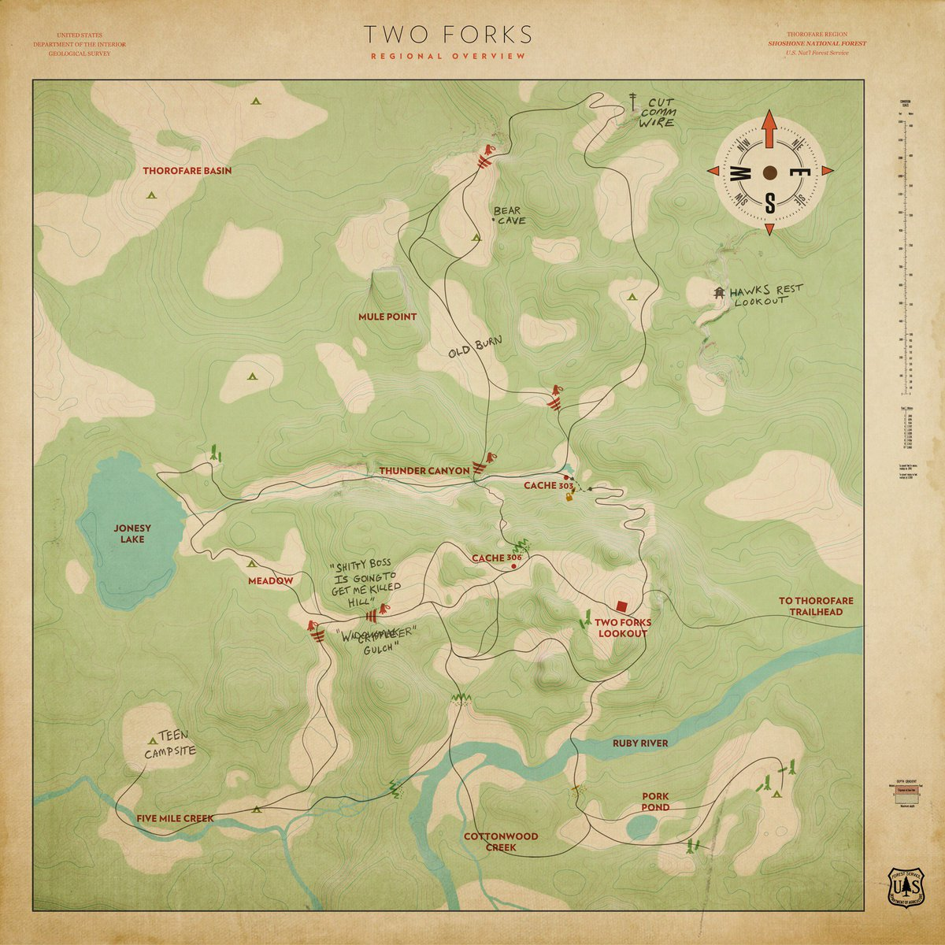

|  |  |
| --- | --- |
| LEVEL | DESCRIPTION OF LEVEL |
| Mule | This part of the map has lots of trees (in the middle of the game, the trees burned down), and big rocks here and there, few loot boxes and as seen from pictures the mountains that are far are very visible. |
| Five Mile Creek | Five Mile Creek is a place with lots of loot boxes and tools that can help you later in the game. The scenery is very much simplistic with trees and a creek in the middle of the terrain. |
| Thunder Canyon | Thunder Canyon is a place where things get interesting. As a player you walk down the canyon not knowing it existed. On the other part of the canyon, Henry finds out about the mysterious old cave. |
| Two Forks Lookout | Two Forks Lookout is a Henry’s safehouse. This is basically his main place where he sleeps and eats, In the watchtower, from where he gets his instructions from Delilah where to go and what to do. |

# **Control Scheme**

On PC Firewatch is played by keyboard and mouse, where of course, consoles are using joysticks.

# **PC controls :**

|  |  |
| --- | --- |
| BUTTON | ACTION IT PERFORMS |
| W | Player moves forward. |
| A | Player moves left. |
| S | Player moves backwards. |
| D | Player moves right. |
| LEFT SHIFT | Bring up radio (walkie talkie). |
| UP ARROW | Cycle up through radio dialog. |
| DOWN ARROW | Cycle down through radio dialog. |
| LEFT MOUSE | Select. |
| M | Brings up map. |
| F | Interact. |
| SPACE | CLIMB |

# **Console controls :**

# **Steam Controller :**

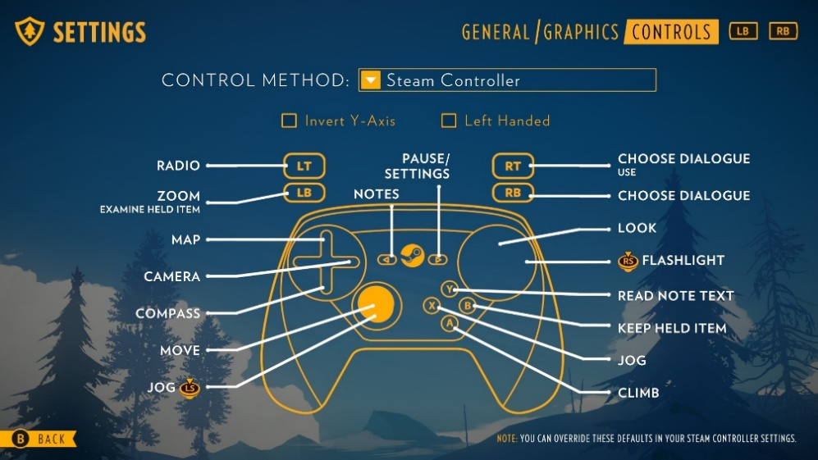

# **DualShock Controller :**



# **Xbox One Controller :**

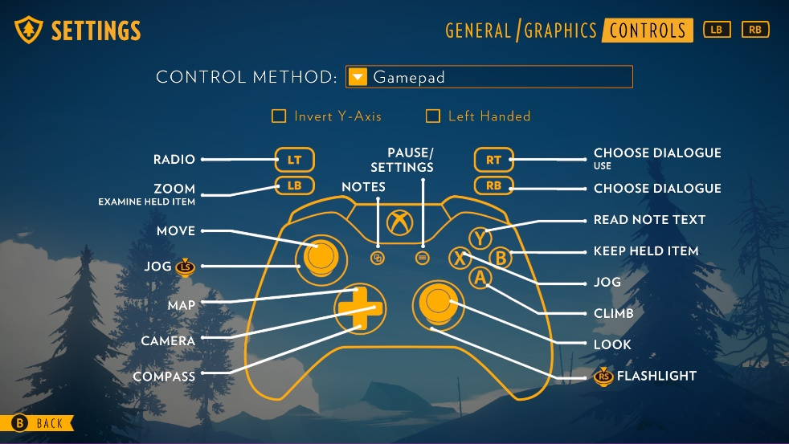

**Game Aesthetics & UI:**

The artstyle of the game is very artistic and aestethic, it is going to be a lowpoly to mid-poly environment of the woods set in hot summer days and nights. It will be based on atmospheric feeling with the player itself as the art is going to be very appealing to the eyes, colliding with atmoshperic, sometimes calm, and sometimes intense music in the background as you interact with objects and explore the story of the game which will twist more and more and become more mysterious each time you start the game.UI of the game is very much simplistic with pretty much all clear hud, the only visible UI in the gameplay is your popup for your radio, and the map that you open up with 'm' key.

# **Schedule & Tasks**

|  |  |  |  |  |
| --- | --- | --- | --- | --- |
| **Tasks to Complete & Schedule** | | | | |
| **Tasks** | **Task Lead** | **Start** | **End** | **% Complete** |
| **Development Phase** | | | | |
| Design |  |  |  |  |
|  | Chris Remo | 12.05.2015 | 15.06.2015 | 40 % |
|  | Jake Rodkin | 12.05.2015 | 15.06.2015 | 50 % |
|  | James Benson | 12.05.2015 | 15.06.2015 | 30 % |
|  | Nels Anderson | 12.05.2015 | 15.06.2015 | 20 % |
| Programmers | Ben Burbank | 12.05.2015 | 16.06.2015 | 20 % |
|  | Nels Anderson | 12.05.2015 | 19.09.2015 | 30 % |
|  | Patrick Ewing | 12.05.2015 | 19.09.2015 | 15 % |
|  | Paolo Surricchio | 12.05.2015 | 19.09.2015 | 10 % |
|  | William Armstrong | 12.05.2015 | 19.09.2015 | 20 % |
| Artists | Jane Ng | 12.05.2015 | 18.09.2015 | 50 % |
|  | Olly Moss | 12.05.2015 | 20.09.2015 | 40 % |
| Writters | Chris Remo | 12.05.2015 | 20.09.2015 | 60 % |
|  | Jake Rodkin | 12.05.2015 | 20.08.2015 | 80 % |
|  | Olly Moss | 12.05.2015 | 20.08.2015 | 70 % |
|  | Sean Vanaman | 12.05.2015 | 20.08.2015 | 40 % |